USA Market Insights: Consumer Shopping Behavior

*Trends in Online Shopping Transactions*

Rohini Sidharth Kulkarni

DATA230 : Data Visualization

Dr. Andrew Bond

**Abstract**

Consumer behavior and shopping habits have undergone significant changes over the years, influenced by factors such as technology, cultural shifts, and economic fluctuations. This abstract explores these behaviors and habits with the help of Python for Exploratory Data Analysis (EDA) and Tableau for visualization. In this project, Python was used for EDA to analyze large datasets that contained information related to consumer preferences, purchases, and demographics. The programming language helped identify key trends and patterns in consumer behavior. The process involved cleaning, processing, and analyzing the data to derive meaningful insights. Python's diverse libraries, including Pandas and NumPy, played a crucial role in handling complex data operations efficiently.

With help of Tableau a powerful data visualization tool to visualize the data. Through interactive dashboards and graphics, Tableau enabled a comprehensive portrayal of consumer behavior and shopping patterns. These visual representations were instrumental in understanding the dynamics of consumer choices and their implications on the market. The findings of this study are significant contributions to the community.

By understanding consumer behavior, businesses can tailor their products and marketing strategies more effectively, leading to enhanced customer satisfaction and loyalty. Additionally, policymakers can use these insights to develop regulations that protect consumer interests and promote fair trade practices. Overall, the integration of Python for EDA and Tableau for data visualization provides a multifaceted approach to studying consumer behavior. This methodology not only enriches the academic understanding of shopping habits but also influences community contribution by informing business strategies and policy-making decisions.

**DataSet Description:**

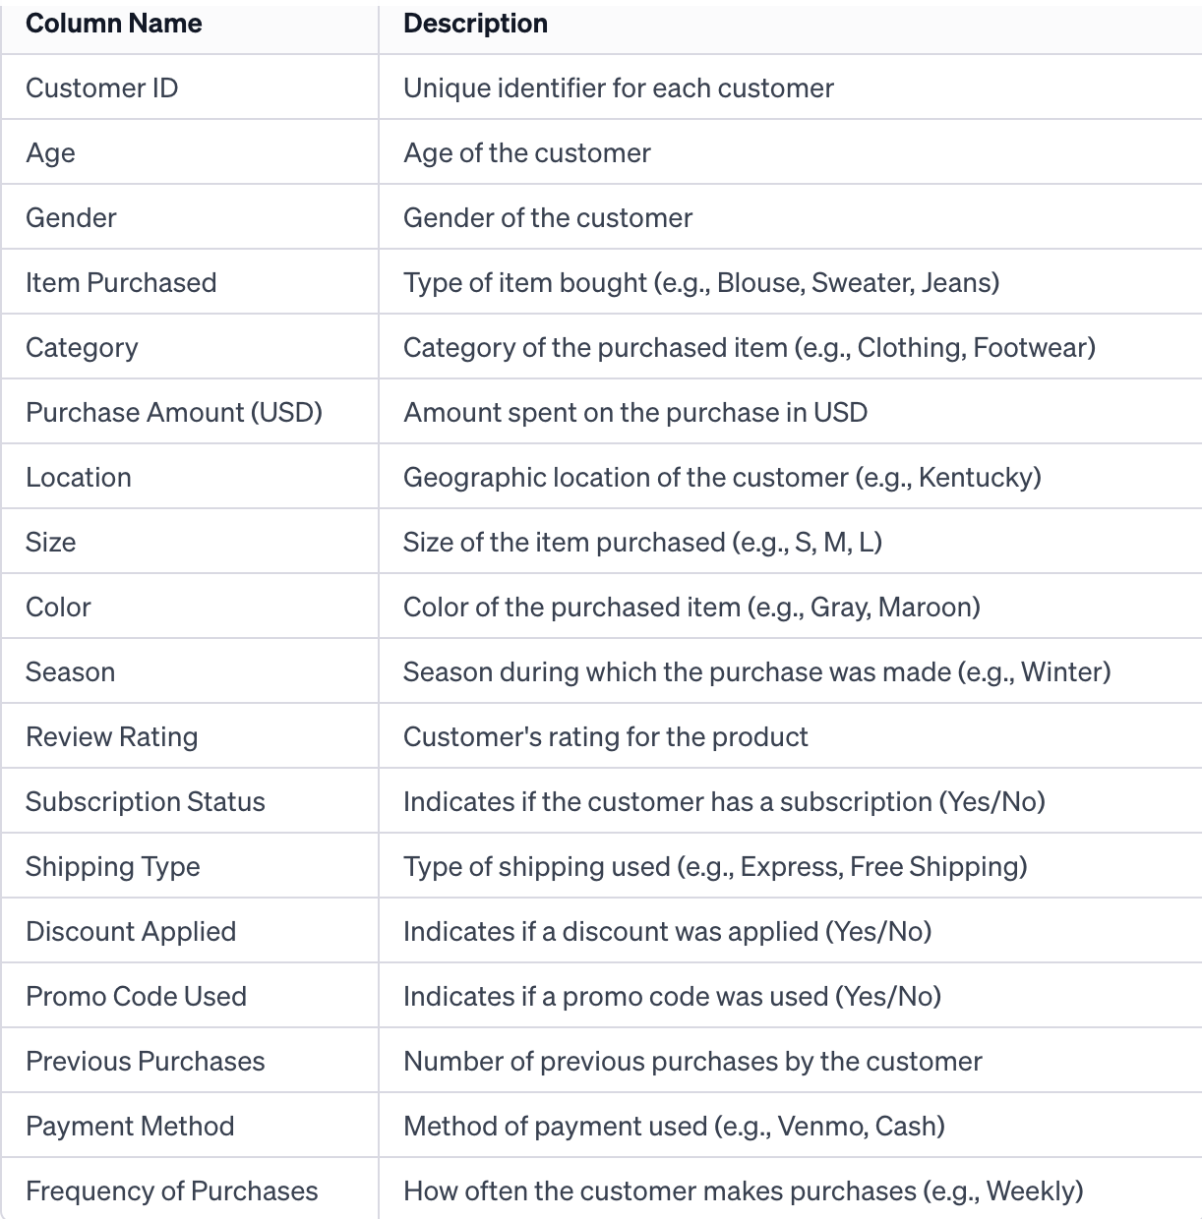

Table 1: Description of the dataset: Consumer Behavior and Shopping Habits

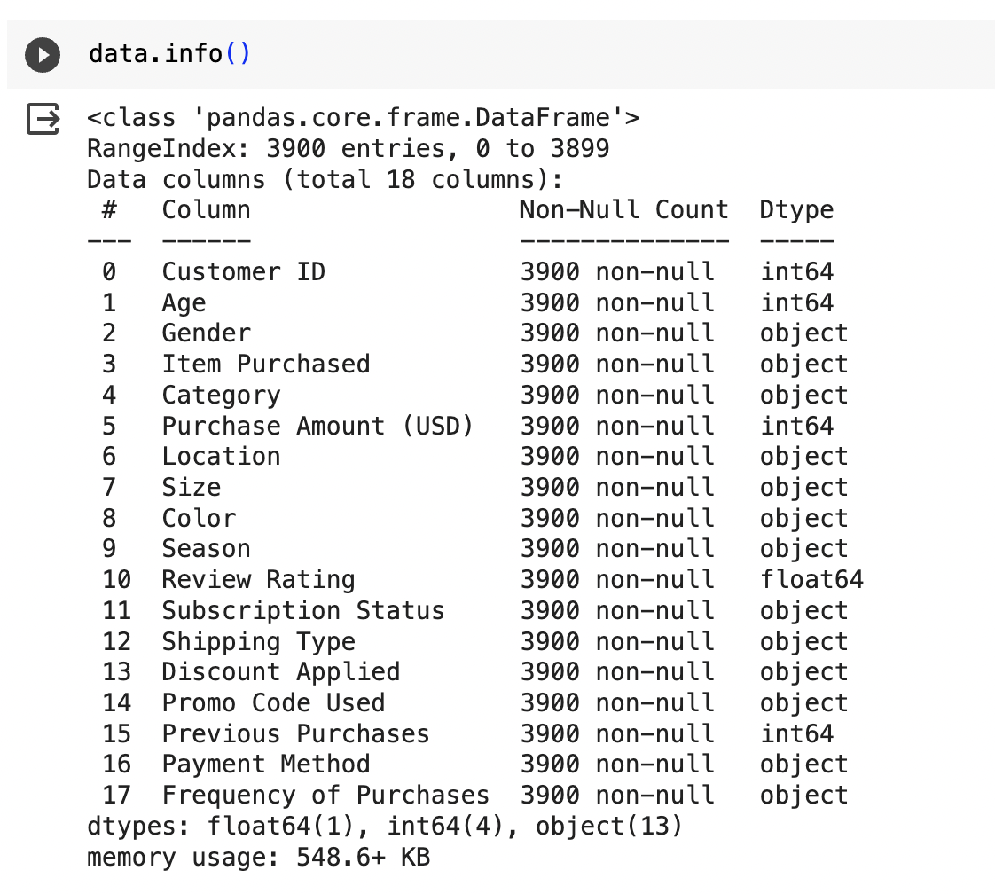

Figure 1: The dataset information about the columns

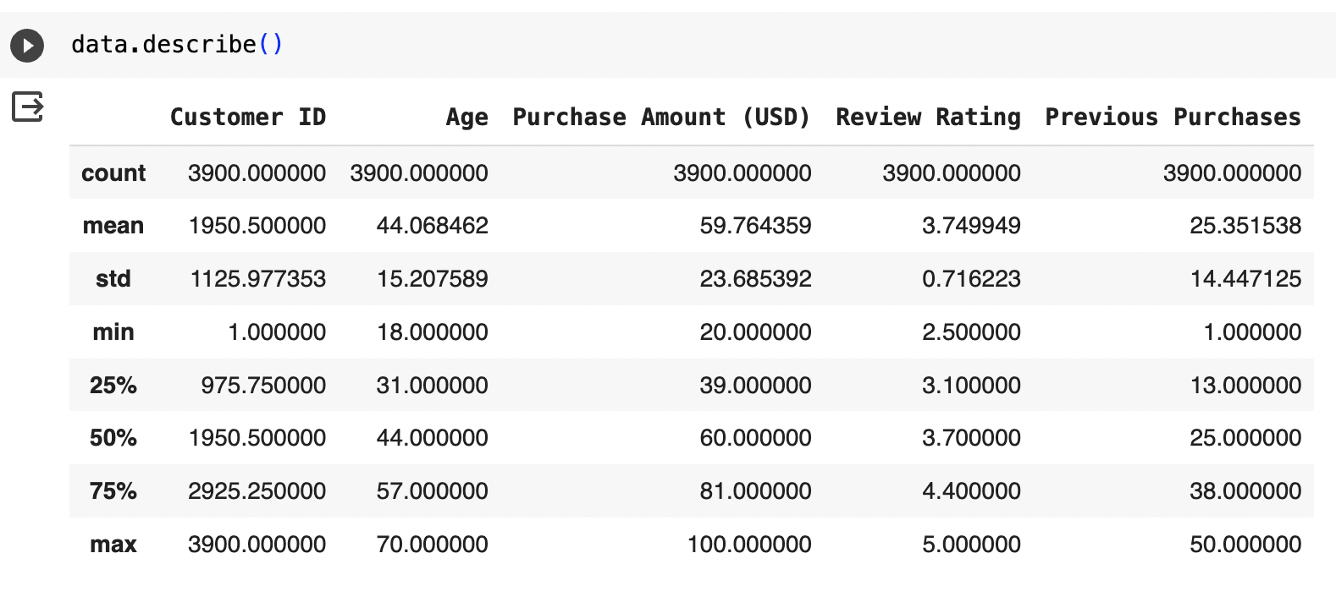

Figure2: Descriptions of the dataset

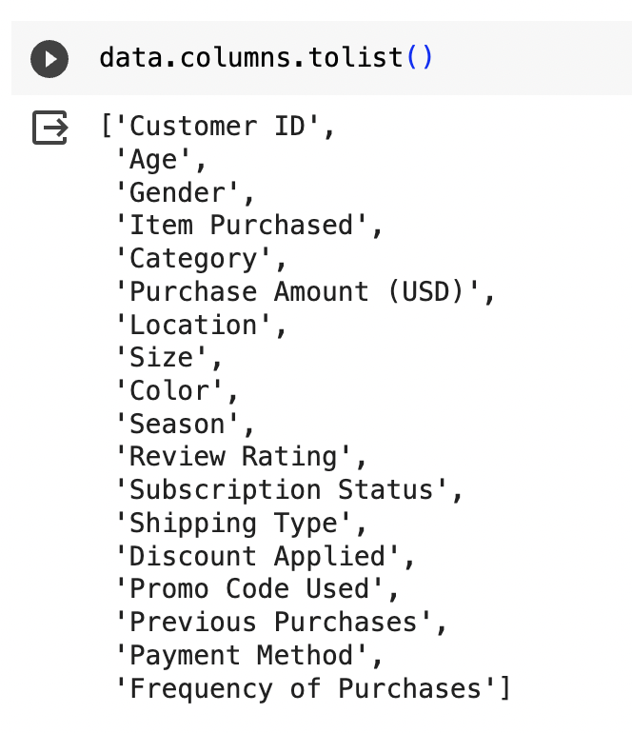

Figure 3: Number of columns in the dataset

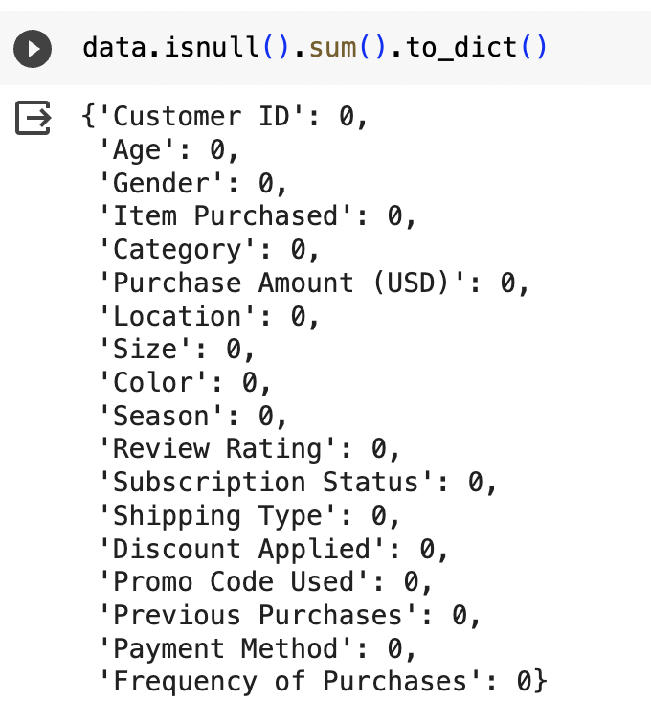

Figure 4: After analyzing the dataset there is no null value

**Worksheet Data Visualization Patterns:**

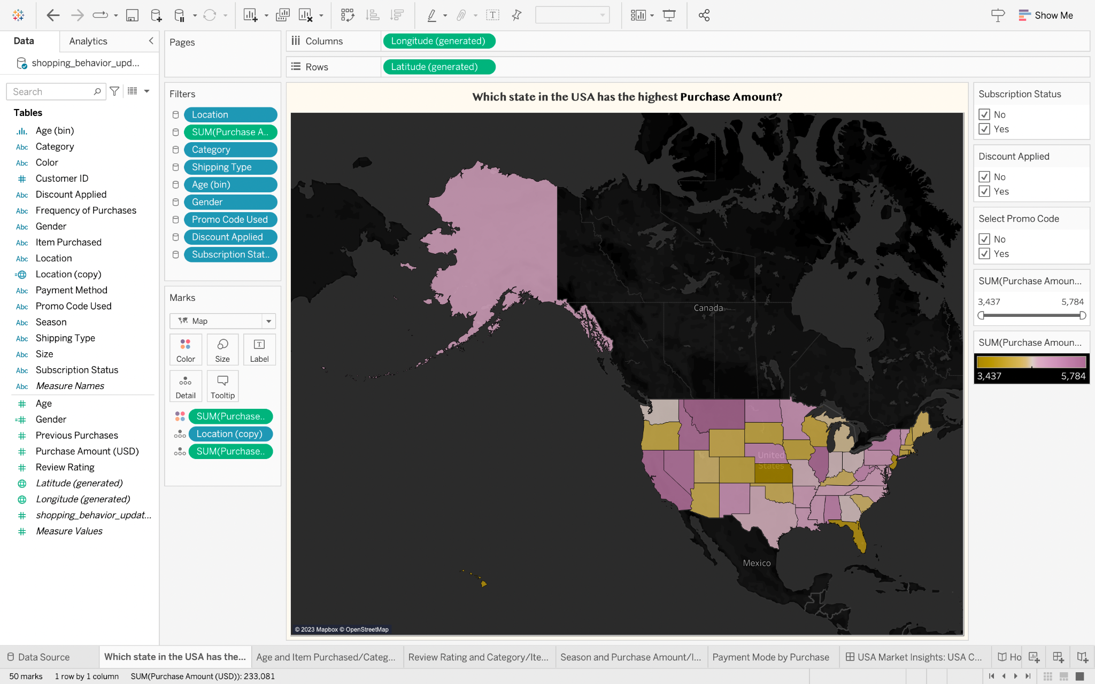

Figure 5: It’s a map-based visualization (“Which state in the USA has the highest Purchase Amount?”)

* Map shows the geographic spending patterns in the USA, with color shading indicating total purchase amounts.
* Some states, such as those color-coded in yellow, appear to have higher purchase amounts, suggesting key markets or higher consumer spending. The side panel includes filters for "Subscription Status," "Discount Applied," and "Select Promo Code."
* The legend indicates a purchase amount ranging from 3,437 to 5,784 USD. The map allows for more detailed data to be accessed interactively, such as detailed purchase amounts, locations, review ratings, etc.
* One can drill down further into the data to see seasonal trends, category preferences, or specific item popularity by state. The title of the map is "Which state in the USA has the highest Purchase Amount?" This indicates that the map is used to analyze purchase amount differences across the USA.
* States are grouped by proximity and color-coded to indicate similar purchase amounts. Interactive elements may provide a sense of connectedness between the data points and specific information.

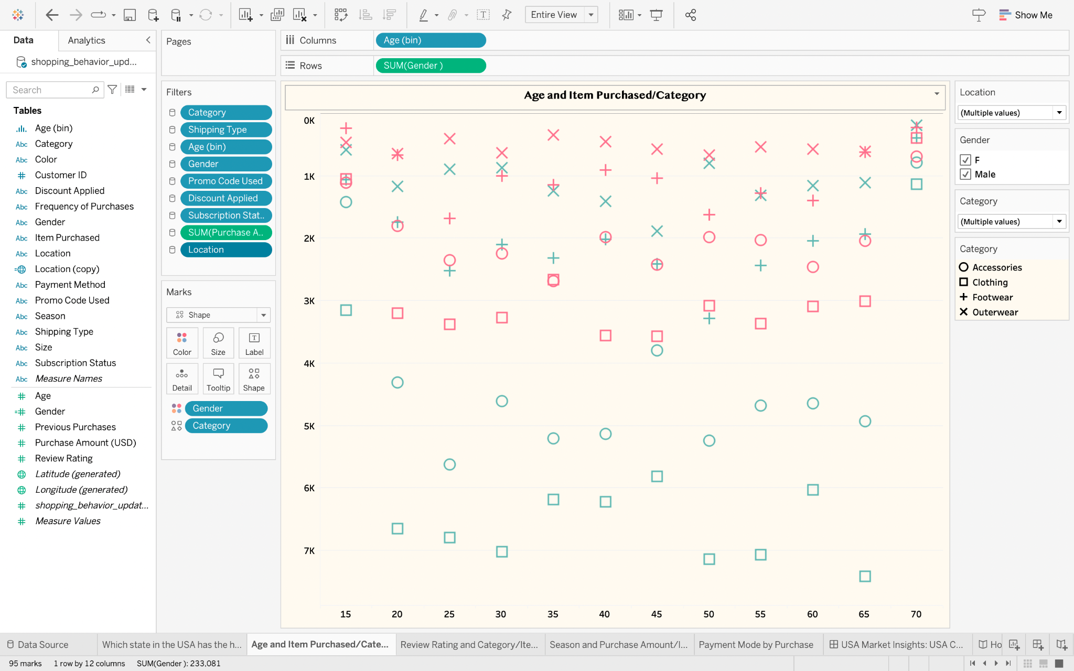Figure 6: Scatter plot visualization (“Age and Item Purchased/Category”)

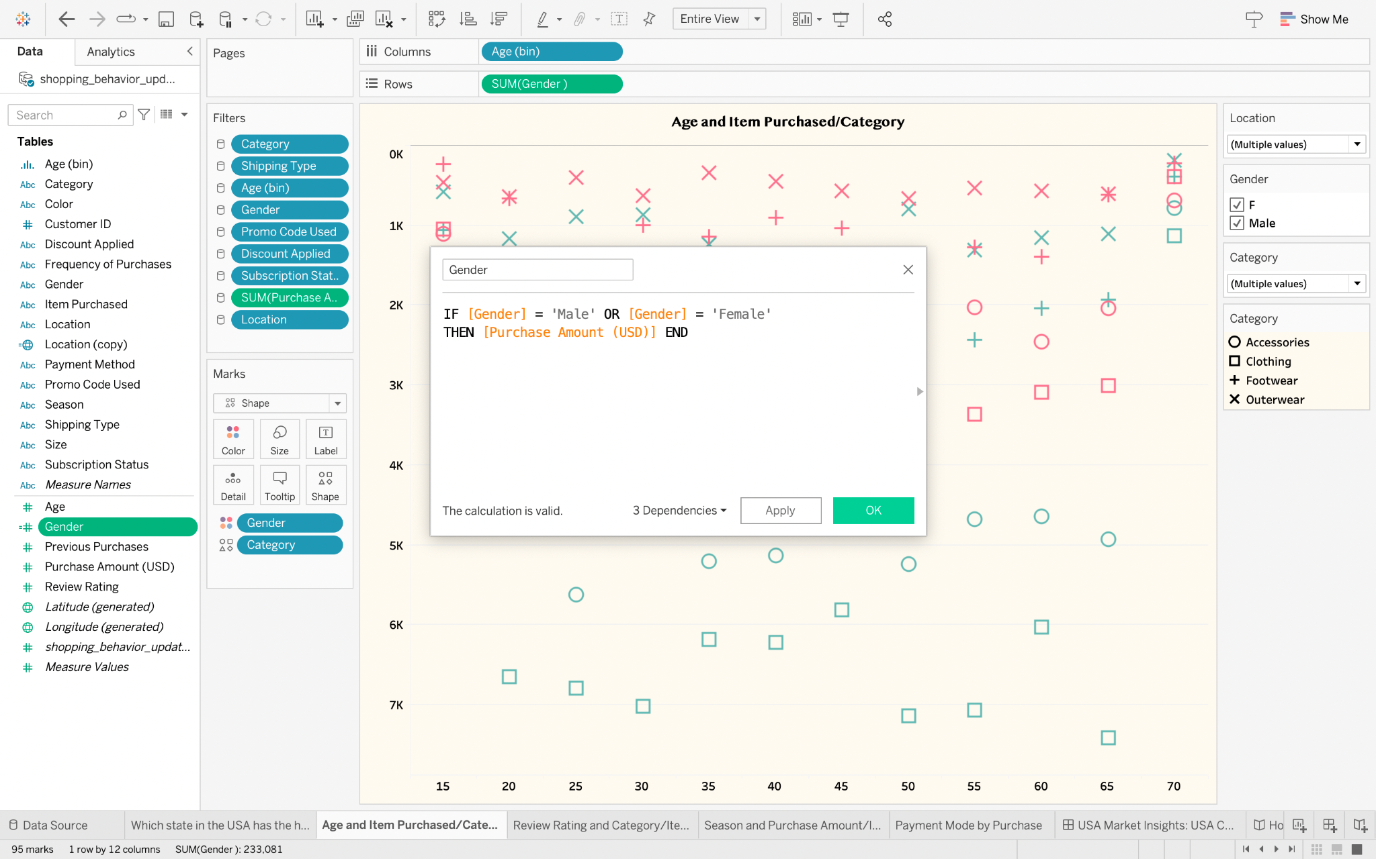

Figure 7: Calculated field for the Gender(Female or Male) to understand the count

* The chart shows the age(bin) distribution of customers ranging from 15 to 70 years.
* A shape represents each purchase event: circles for Accessories, squares for Clothing, crosses for Footwear, and diagonal crosses for Outerwear.
* Colors differentiate between genders, possibly pink for females and blue for males.
* Clothing is purchased across all age groups and genders, while Footwear shows a concentration in the middle age range. Accessories appear less frequently and are more common in the younger and older age groups. Outerwear is the least represented category.
* The visualization primarily utilizes the principle of similarity to quickly group data points based on the category of items purchased. The use of colors, if it indeed indicates gender, is also an application of this principle.
* The lack of proximity as a grouping implies a wide distribution of purchases across age groups, indicating no strong age clustering within each category.

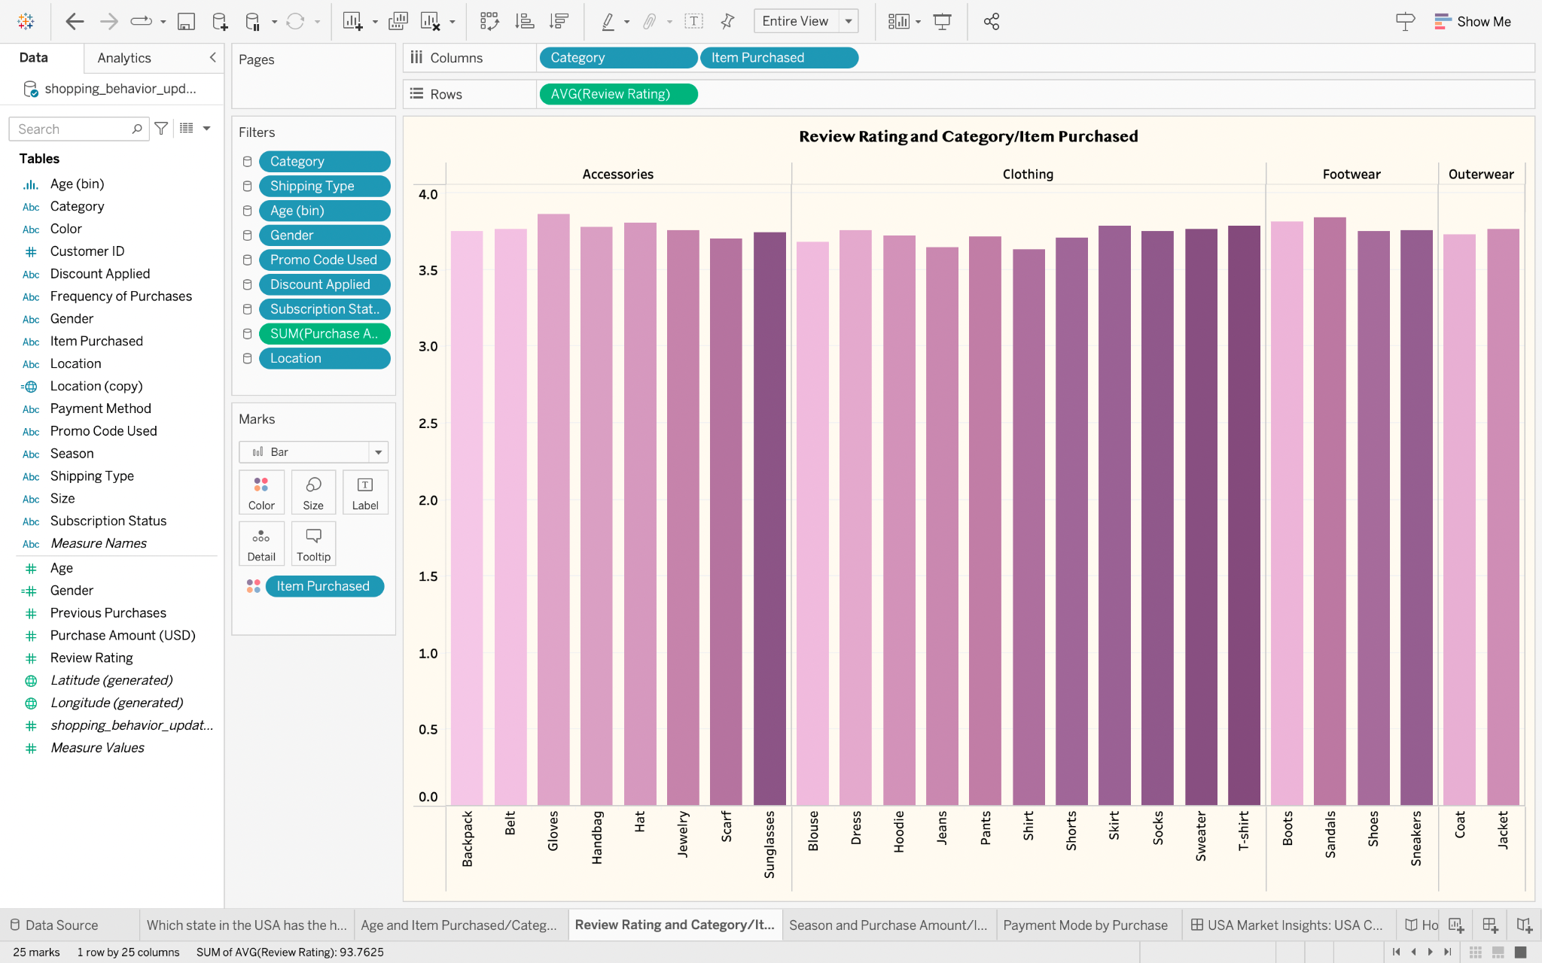

Figure 8: Bar-Chart Visualization(“Review Rating and Category/Item Purchased”)

* This chart shows different categories of items, each represented by a unique color, with each bar representing the average review rating for an item.
* Accessories like Jewelry, Scarf, and Sunglasses have relatively high review ratings, as do Clothing items like Pants, Shirts, and T-Shirts.
* Footwear, including Boots and Shoes, generally has high ratings, while Outerwear items like Coats and Jackets have some of the highest average ratings.
* The chart uses Gestalt principles such as proximity, similarity, and enclosure to help viewers compare and contrast items based on their perceived quality or satisfaction.

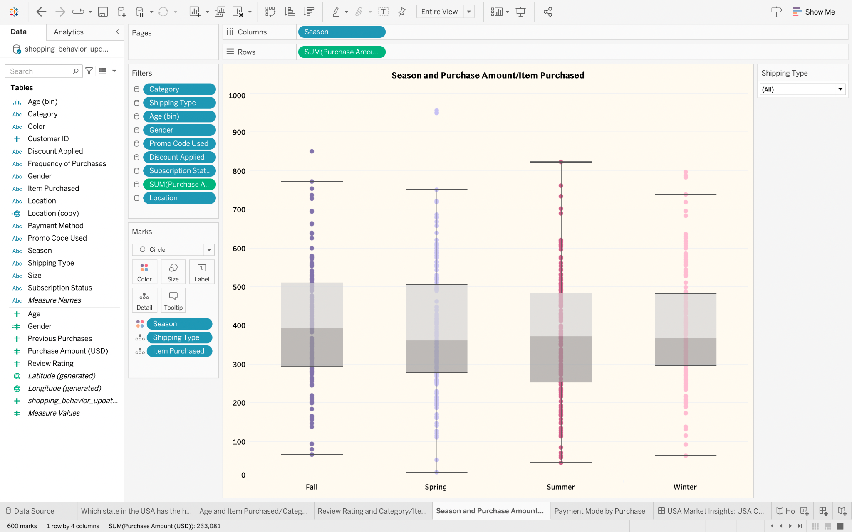

Figure 9: Box Plot Visualization(“Season and Purchase Amount/Item Purchased”)

* This box-and-whisker plot shows purchase amounts for different seasons: Fall, Spring, Summer, and Winter. Summer and Winter have higher median purchase amounts than Fall and Spring.
* Winter has the largest interquartile range, with many outliers, while Spring has the lowest median purchase amount.
* The plot effectively clusters data points by season and uses similarity to ensure easy comparison.

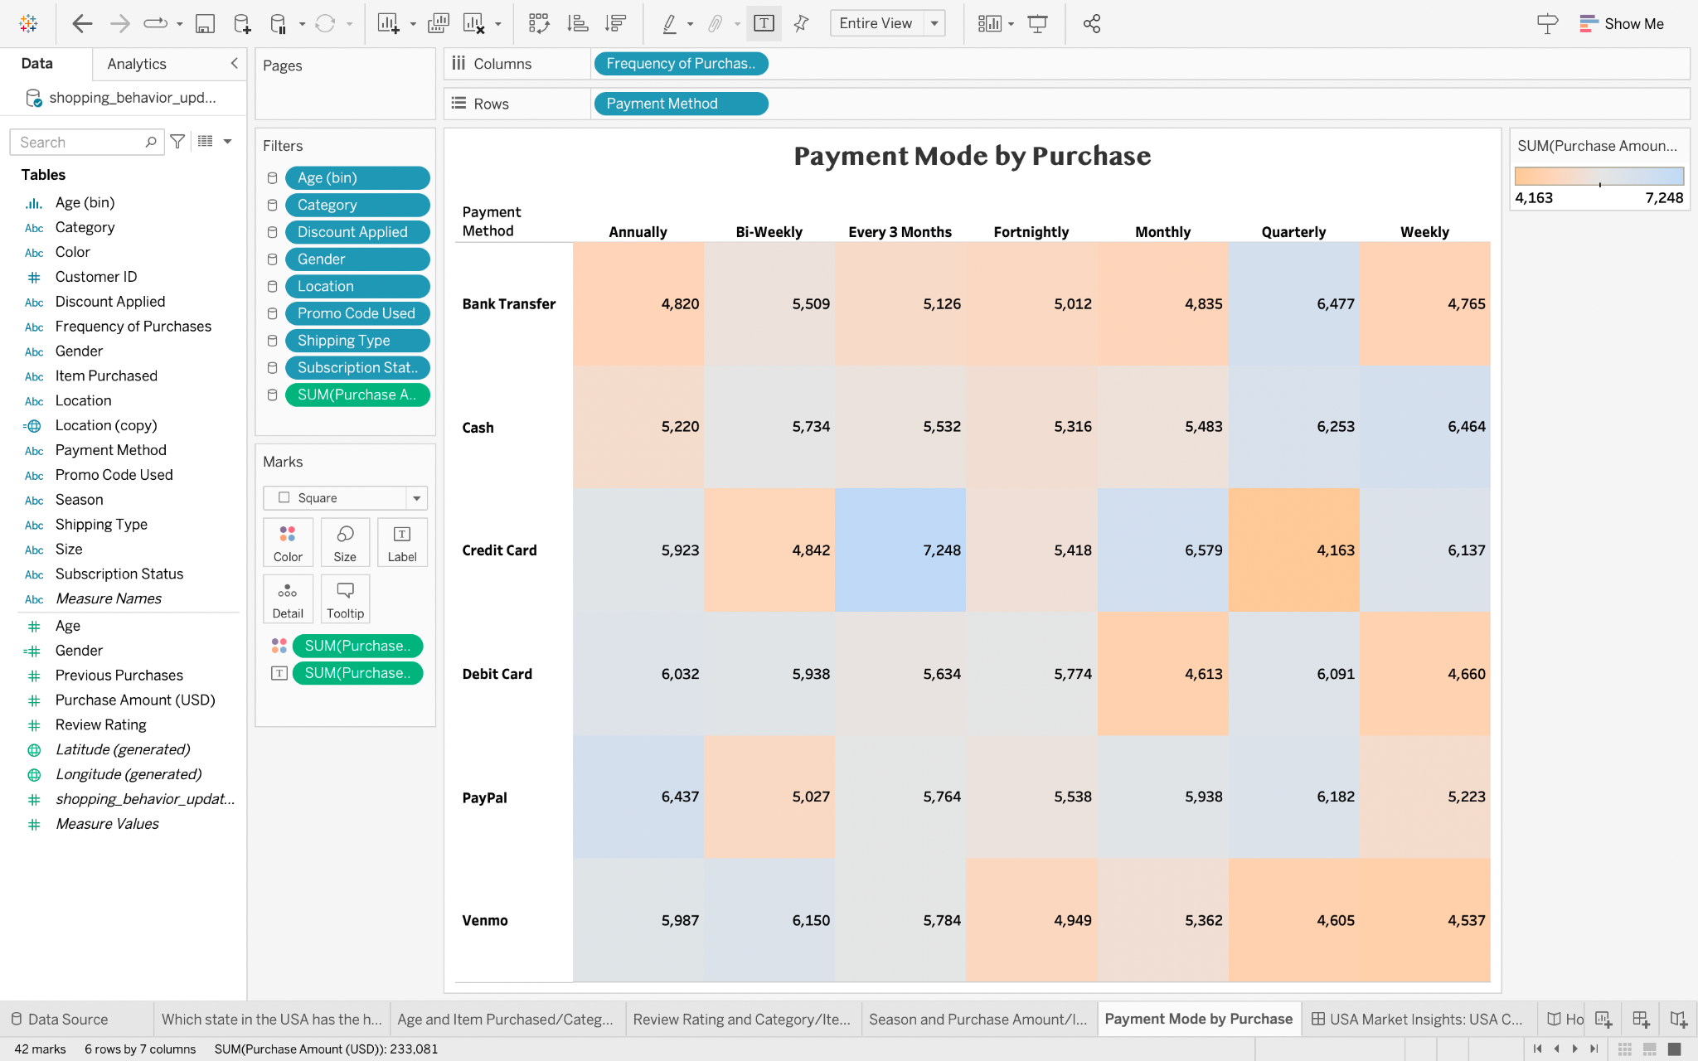

Figure 10: Heatmap Text Table Visualization (“Payment Mode by Purchase”)

* This heatmap shows the relationship between payment methods and the frequency of purchases, with darker colors indicating higher sums of purchase amounts.
* Credit and Debit cards are the most frequently used payment methods across all purchase frequencies.
* The highest sum of purchase amounts for most payment methods occurs with quarterly and weekly purchases.
* PayPal and Venmo show a higher sum of purchase amounts for less frequent purchases, while Cash is used regularly for bi-weekly and weekly purchases.
* The heatmap effectively uses the Gestalt principles of proximity and similarity to convey patterns in the data.

**Interactive Dashboard:**

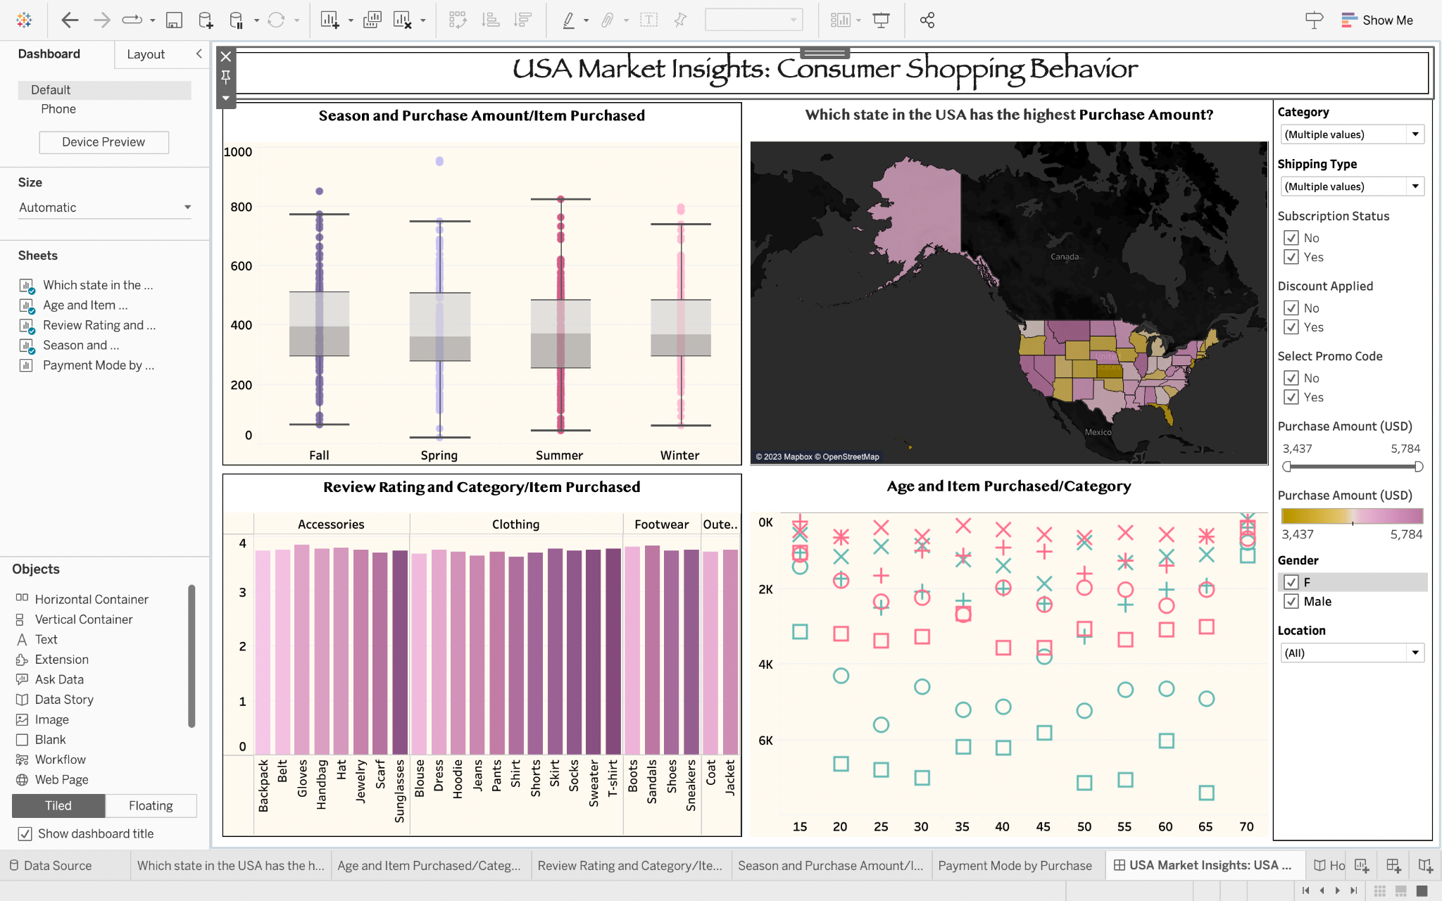

Figure 11: Dashboard (“USA Market Insights: Consumer Shopping Behavior”)

* The image provided is a composite dashboard with a map, box plot, bar chart, and scatter plot. They show consumer shopping behavior insights in the USA market. The map shows states with the highest purchase amounts.
* The box plot displays purchase distribution across seasons. The bar chart illustrates average review ratings for different items and categories.
* The scatter plot shows the customer age-category item purchased relationship.
* Patterns Observed:

- Geographic spending variations

- Seasonal spending differences

- Consistently higher review ratings for specific items

- Diverse age and gender distribution among customers

**Story: How do purchases vary by season?**

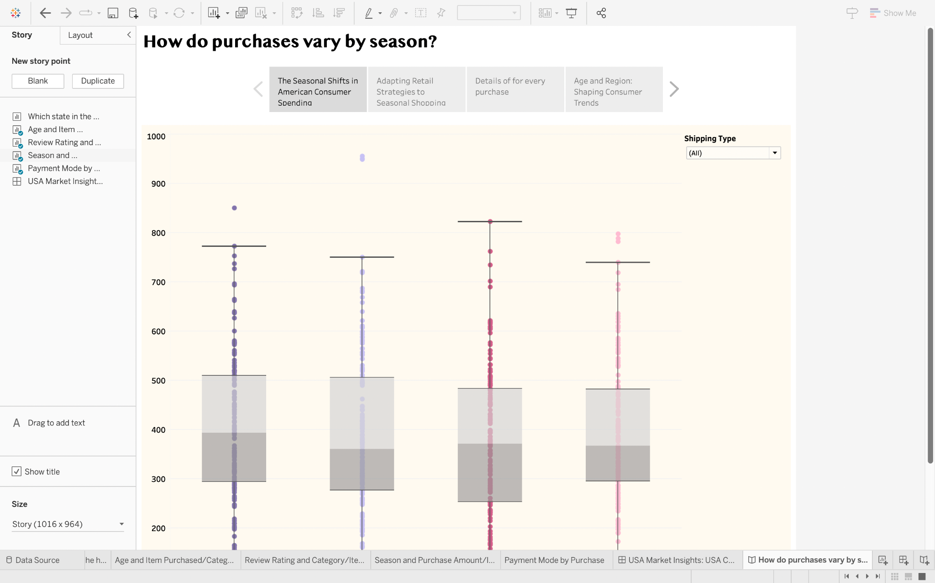

Figure 12: Storyline: “The Seasonal Shifts in American Consumer Spending”

* A box-and-whisker plot shows the distribution of purchase amounts across different seasons, indicating variations in spending. Winter and Summer may show higher median purchase amounts and a wider range of spending, suggesting peak shopping periods due to holidays or seasonal sales.

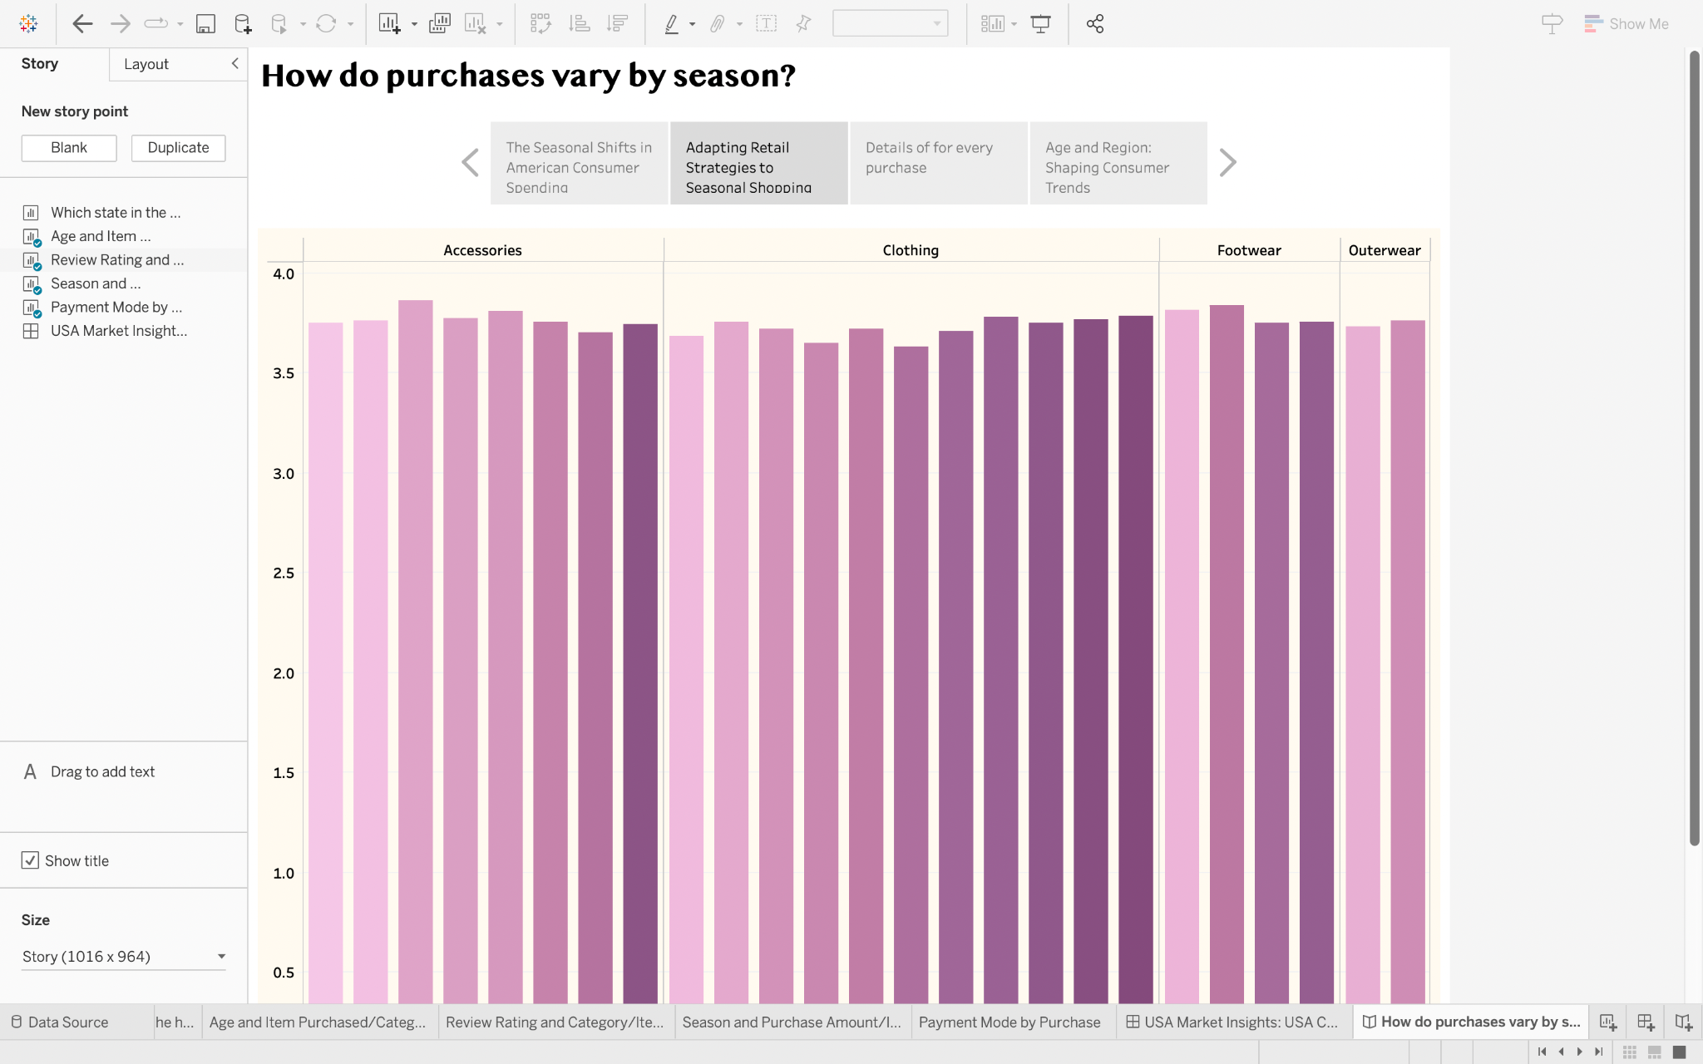

Figure 13: Storyline: “Adapting Retail Strategies to Seasonal Shopping”

* A heatmap can show payment methods and purchase frequency, highlighting total amounts spent. Retailers can analyze this data to identify patterns and tailor their strategies, such as offering promotions or discounts that align with these patterns.

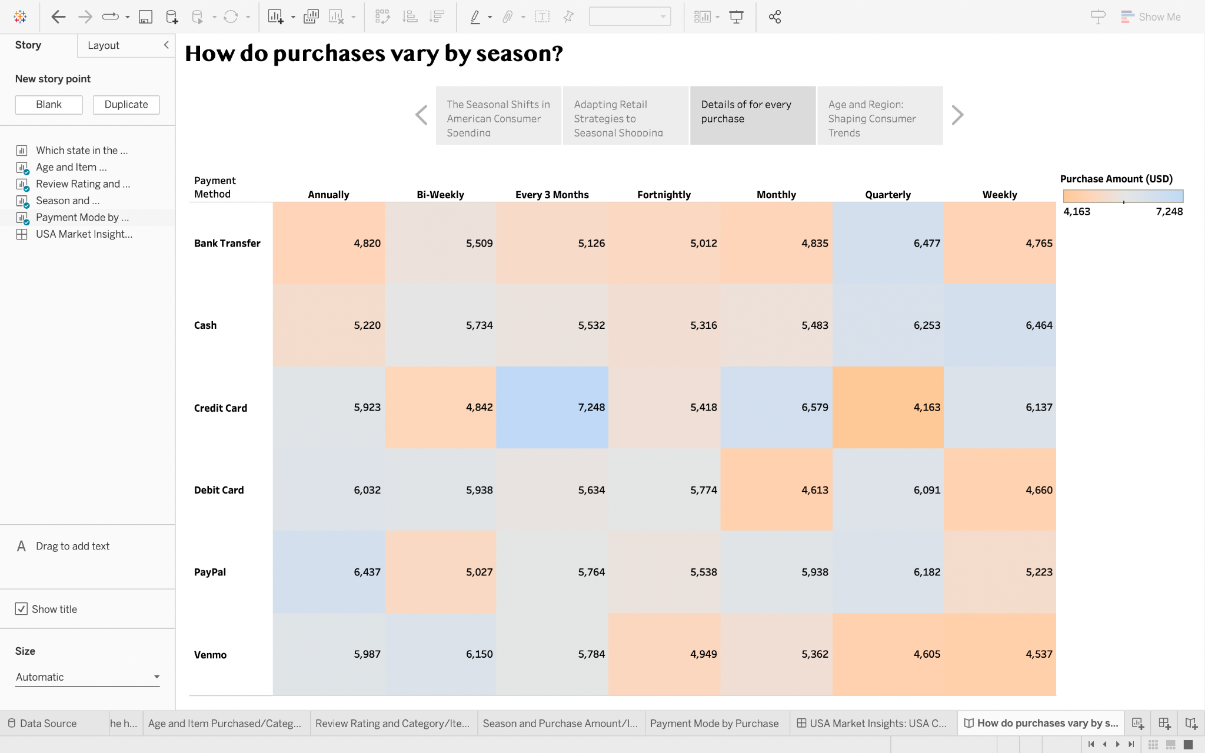

Figure 14: Storyline: “Details of for every purchase”

* One way to illustrate the relationship between customer age and the category of items purchased is through a scatter plot that displays individual data points. This can reveal patterns that reflect the diversity in consumer preferences across different age groups, with certain item categories appealing more to specific age segments.

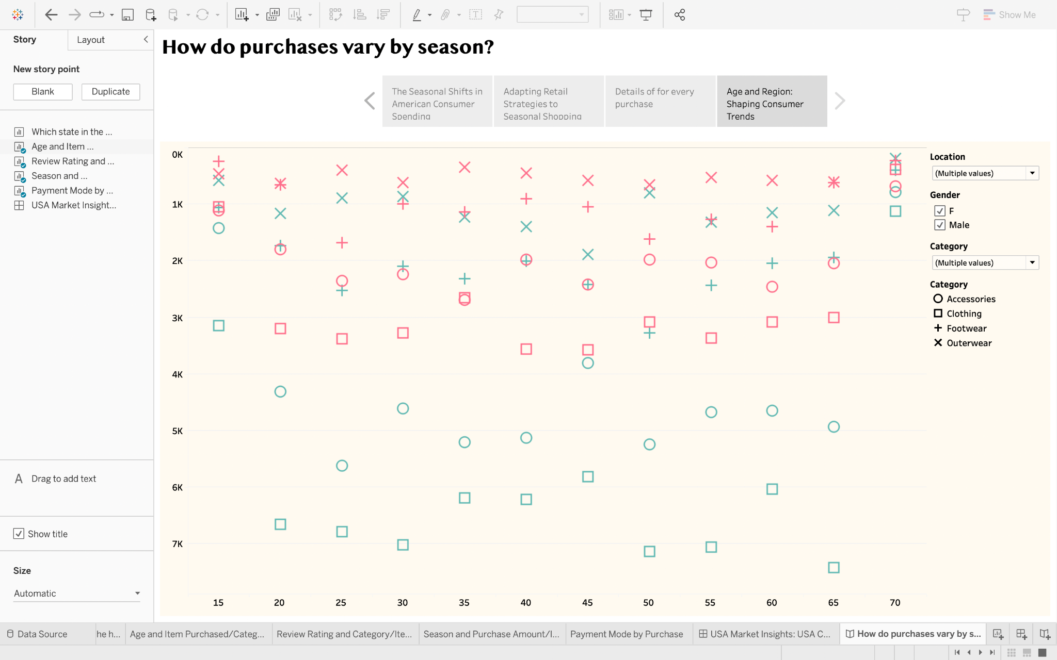

Figure 15: Storyline “Age and Region: Shaping Consumer Trends”

* The scatter plot is a great tool to analyze the impact of age and regional factors on shopping behavior. By using different symbols for categories and colors for gender, the plot can reveal interesting patterns. For example, it might demonstrate that certain age groups have a preference for specific types of items, or that gender preferences vary depending on the region.

**Use/Test Cases:**

After visualization to validate the insights derived from the consumer shopping behavior data, test cases can be used to evaluate different scenarios. Here are some hypothetical test cases:

**Test case A. Seasonal Shifts/ Vacations in American Consumer Spending:**

1. Test whether Winter holiday sales significantly increase purchase amounts compared to other seasons.

2. Measure the change in consumer spending during Summer promotional events like "Back to School", and “Black Friday” sales.

**Test case B. Adapting Retail Strategies to Seasonal Shopping:**

3. Assess the effectiveness of targeted promotions for users preferring digital payment methods during high-spending seasons.

4. Determine if offering more frequent sales or loyalty rewards can increase purchase frequency in off-peak seasons.

**Test case C. Details for Every Purchase:**

5. Analyze if customers in the 18-25 age group are more likely to purchase fashion items compared to other age groups.

6. Examine the correlation between review ratings and repeat purchases for the same category of items.

**Test case D. Age and Region: Shaping Consumer Trends:**

7. Observe if certain regions have a higher propensity to purchase winter clothing and if this correlates with colder climates.

8. Verify if older demographics in specific regions spend more on health-related products.

**Conclusion**

US consumer spending varies seasonally. Retailers can time marketing efforts to coincide with higher spending periods. Payment methods vary with credit/debit cards being most common. Retailers could offer more payment options in seasons with higher alternative payment usage. Retailers should customize offerings for different demographics. Regional characteristics influence consumer trends, which can inform targeted marketing and product distribution strategies.

Retailers must consider seasonality, payment preferences, demographics, and regional differences when creating a strategy. By adapting to these patterns and offering tailored experiences, retailers can improve sales and customer engagement.

**Github: “** [**https://github.com/ProBag**](https://github.com/ProBag)**”**

**Reference**

1. Kaggle dataset: <https://www.kaggle.com/datasets/zeesolver/consumer-behavior-and-shopping-habits-dataset?select=shopping_behavior_updated.csv>
2. Lecture Notes from DATA230
3. Medium articles:

<https://medium.com/@saha75749/understanding-the-psychology-behind-consumer-behavior-649dab4752d9>

<https://medium.com/@programming.nadya/ultimate-guide-to-understand-the-key-determinants-of-consumers-buying-behaviour-bca6509cbfb3>